**WEEK – 2 PL/SQL PROGRAMMING**

**EXERCISE-1 CONTROL STATEMENTS**

**STEP 1: CREATE TABLE**

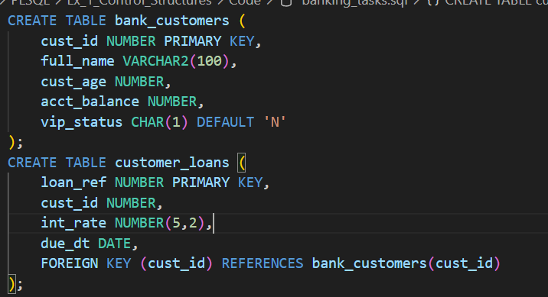

**STEP 2: INSERT DATA**

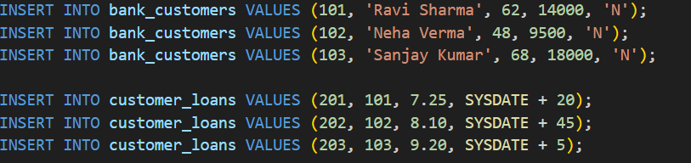

**STEP 3: DISCOUNT FOR CUSTOMERS OVER 60**

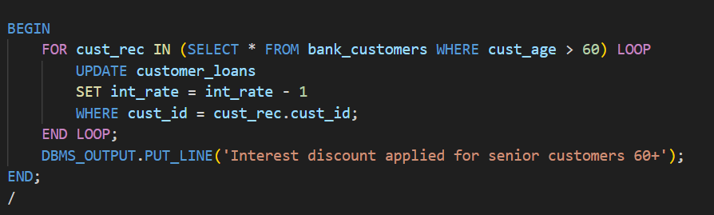

**STEP 4: PROMOTE CUSTOMERS TO VIP BASED ON BALANCE**

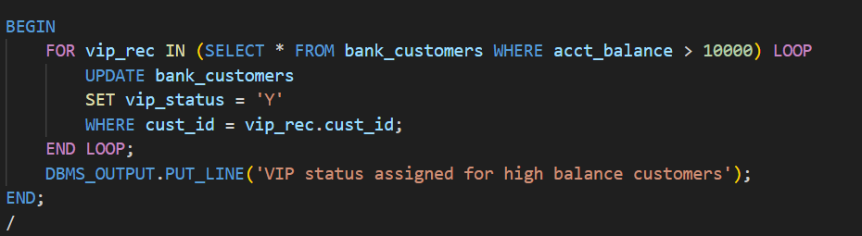

**STEP 5: LOAN DUE DATE REMINDER (NEXT 30 DAYS)**

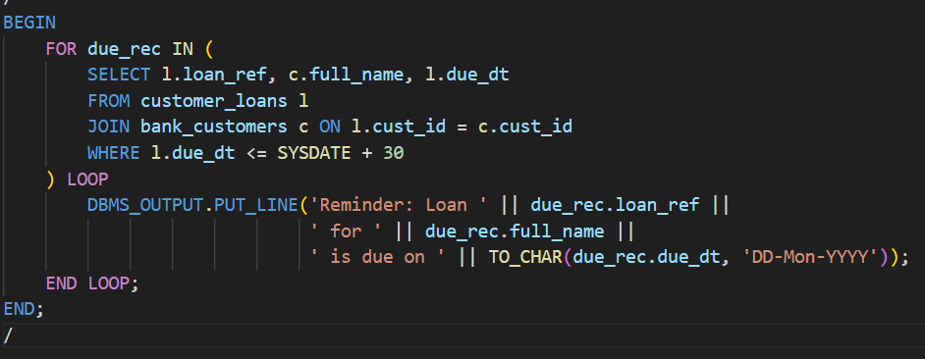

**OUTPUT:**

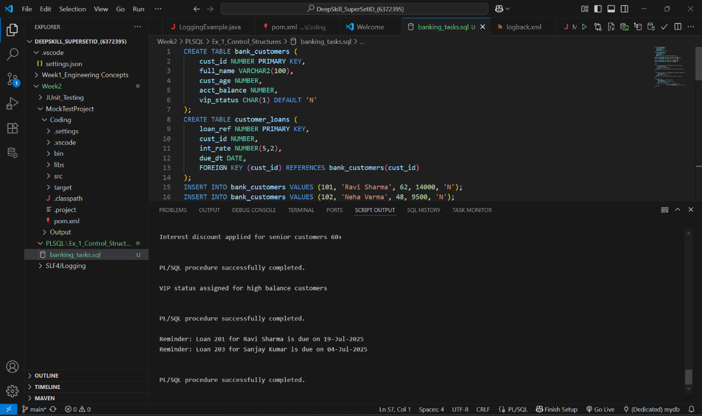

**EXERCISE 3: STORED PROCEDURES**

**STEP 1: CREATE TABLE**

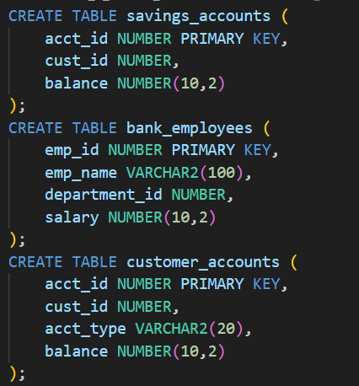

**STEP 2: INSERT DATA**

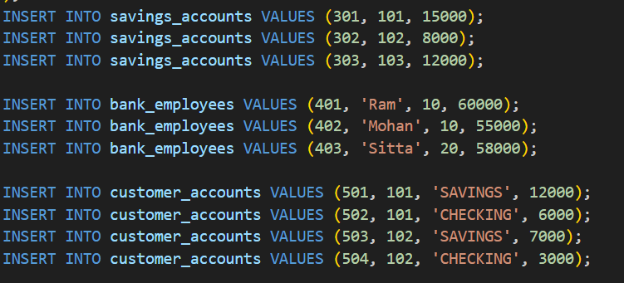

**STEP 3: PROCEDURE TO PROCESS MONTHLY INTEREST**

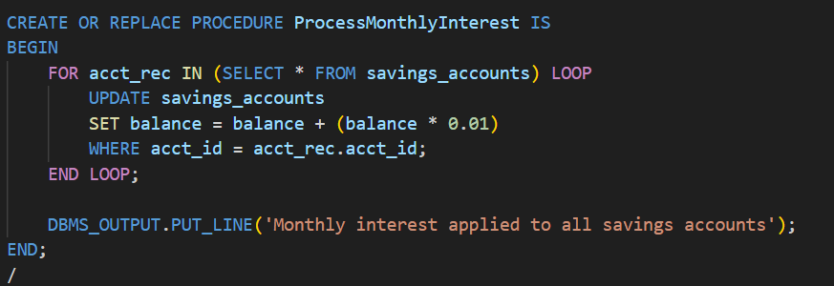

**STEP 4: PROCEDURE TO APPLY BONUS FOR EMPLOYEES**

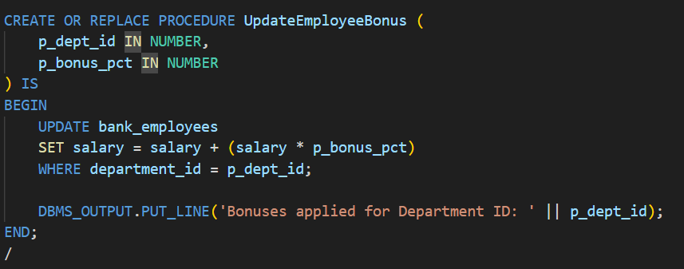

**STEP 5: PROCEDURE FOR FUND TRANSFER**

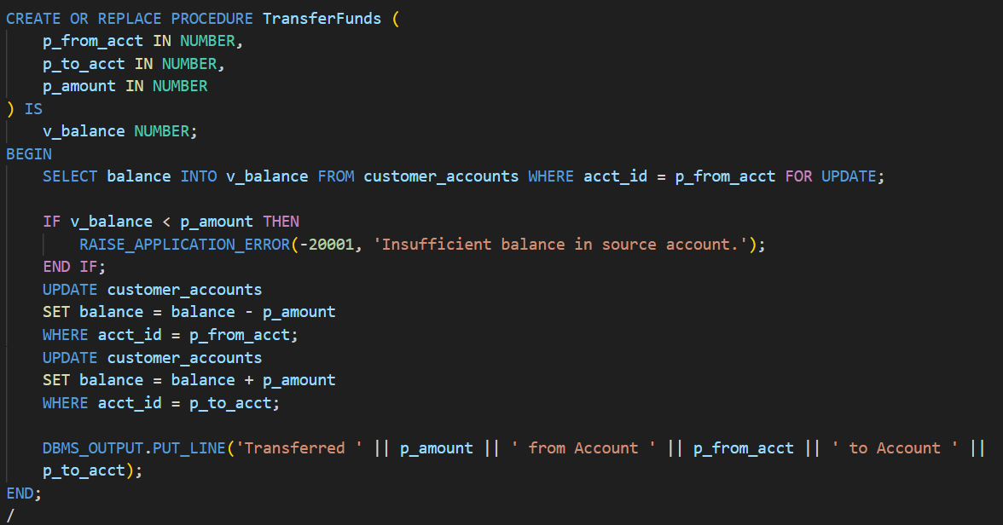

**OUTPUT:**

